EMERGING METHODS FOR EARLY DETECTION OF  FOREST FIRES

**A PROJECT REPORT**

***Submitted by***

**SOWMIYA SREE. S (111619106135)**

**SRAVANI. G (111619106136)**

**SANDHIYA. R (111619106121)**

**VAISHALI. N (111619106152)**

**TEAM ID : PNT2022TMID14761**

**ELECTRONICS AND COMMUNICATION ENGINEERING**

|  |  |  |  |
| --- | --- | --- | --- |
| **S.NO** | **TABLE OF CONTENT** | |  |
| **1** | **INTRODUCTION** | |  |
|  | 1.1 | Project Overview |  |
|  | 1.2 | Purpose |  |
| **2** | **LITERATURE SURVEY** | |  |
|  | 2.1 | Existing problem |  |
|  | 2.2 | Reference |  |
|  | 2.3 | Problem Statement Definition |  |
| **3** | **IDEATION & PROPOSED SOLUTION** | |  |
|  | 3.1 | Empathy Map Canvas |  |
|  | 3.2 | Ideation &Brainstorming |  |
|  | 3.3 | Proposed Solution |  |
|  | 3.4 | Problem Solution Fit |  |
| **4** | **REQUIREMENT ANALYSIS** | |  |
|  | 4.1 | Functional requirements |  |
|  | 4.2 | Non-Functional requirements |  |
| **5** | **PROJECT DESIGN** | |  |
|  | 5.1 | Data Flow Diagrams |  |
|  | 5.2 | Solution & Technical Architecture |  |
|  | 5.3 | User Stories |  |
| **6** | **PROJECT PLANNING & SCHEDULING** | |  |
|  | 6.1 | Sprint Planning & Estimation |  |
|  | 6.2 | Sprint Delivery Schedule |  |
|  | 6.3 | Reports from JIRA |  |
| **7** | **CODING & SOLUTIONING (Explain the features**   **added in the project along with code)** | |  |
|  | 7.1 | Feature 1 |  |
|  | 7.2 | Feature 2 |  |
|  | 7.3 | Database Scheme (if applicable) |  |
| **8** | **TESTING** | |  |
|  | 8.1 | Test Cases |  |
|  | 8.2 | User Acceptance Testing |  |
| **9** | **RESULT** | |  |
|  | 9.1 | Performance Metrics |  |
| **10** | **ADVANTAGES &DISADVANTAGES** | |  |
| **11** | **CONCLUSION** | |  |
| **12** | **FUTURE SCOPE** | |  |
| **13** | **APPENDIX** | |  |
|  |  | Source Code |  |
|  |  | GitHub & Project Demo Link |  |

**1.INTRODUCTION**

* 1. **PROJECT OVERVIEW**

Forest fire is a dangerous condition when an uncontrolled, unexpected fire occurs in forests. It is extremely spontaneous and very difficult to control that damages millions of hectares of land and poses serious dangers not only to the ecosystem but also to humans. It is difficult to predict and detect forest fires in sparsely populated forest areas and it is more difficult when the prediction is done using ground-based models like cameras. Satellites can be an important source of data prior to and also during the fire due to their reliability and efficiency. The various rreal-timeforest fire detection and prediction approaches results in the goal of informing the local fire authorities.

**1.2.PURPOSE:**

Forest fires have become a serious threat to mankind. Besides providing shelter and protection to a large number of living beings, they have been a major source of food, wood, and a great supply of other products. Since ancient times forests have played an important role in social, economic, and religious activities and have enriched human life in a variety of ways both material and psychological. To protect our nature from these rapidly rising forest fires, we need to be cautious enough of every decision we take which could lead to a disastrous end, once and for all. So for the early detection of forest fires, we propose an image recognition method based on Convolutional Neural Networks (CNN).

**2. LITERATURE SURVEY**

**2.1.EXISTING METHOD:**

|  |  |  |  |
| --- | --- | --- | --- |
| **S.NO** | **AUTHOR** | **TITLE** | **NAME OF JOURNAL** |
| 1. | Medi RahuL, Karnekanti Shiva, SakethAttiliSanjeet and Nenavath Srinivas Naik. | Early Detection of Forest fire using Deep Learning. | 2020.IEEE REGION10 Conference(TENCON),2020,pp.  11361140,doi:10.1109/tencon  50793.2020.9293722. |

* The system involves pre-processing the image data and applying data augmentation such as shearing, flipping, etc.
* It uses models like VGG16 , ResNet50 , and DenseNet121 for the classification of images.
* The model initially divides the train and test sets in 80% and 20% and then sent to the pre-processing phase, where finally it is trained to classify them into two classes fire and non-fire.
* By using the optimal learning rate the proposed model was able to achieve a training set accuracy of 92.7% and an est set accuracy of 82.57%.

|  |  |  |  |
| --- | --- | --- | --- |
| **S.NO** | **AUTHOR** | **TITLE** | **NAME OF JOURNAL** |
| 2. | Byron Arteaga, Mauricio Diaz, Mario jajoa, University of Naino Pasto Columbia . | Deep Learning  Applied forest  Fire Detection. | 2020 IEEE International Symposium on signal processing and information Technology(ISSPIT),2020,pp,  16,doi:10,1109/ISSPIT51521.2020.9408859. |

* The data processing was done through open source programming language Python, the cloud service Googlecollab, and deep learning algorithms using Pytorch's library.
* After the data augmentation and pre-processing of the training image, three types of transformation takes place cropping of the image, rotating of an image, and normalizing of the image.
* The classification of images is done by using the pre-trained models of ResNet and VGG pre-trained models.
* To validate the performance of each pre-trained model the k-fold method is used.
* The model obtained during the validationis sent to Raspberry to test its functionality.

|  |  |  |  |
| --- | --- | --- | --- |
| **S.NO** | **AUTHOR** | **TITLE** | **NAME OF JOURNAL** |
| 3. | Raghad k. Mohammed(Department of Basic sciences,college of Density, University Baghdad,Baghdad,Iraq). | A Real-time forest fire and  Smoke detection  System Using  Deep Learning. | International Journal of Nonlinear Analysis and Application 13.1(2022):2053-  2063. |

* The proposed framework aims to detect smoke and fire based on the images received from the video stream from the Raspberry Pi
* Pre-processing of image data.
* Image data augmentation (Scale, horizontal flip, and vertical flip).
* Pre-trainingng model imagenet dataset ->{inception-ResNet-V2}.
* By fine-tuning the above two steps we have to send that to the fully connected layer with softmax.
* we can view the model accuracy as instead.

|  |  |  |  |
| --- | --- | --- | --- |
| **S.NO** | **AUTHOR** | **TITLE** | **NAME OF JOURNAL** |
| 4. | Suhas.G ,Chetan Kumar,Abhishek.B.S, Digvijay Gowda.K.A, Prajwal.R . student of Department of Computer Science and Engineering, Maharaja Institute of Technology Mysore, Karnataka,India | Fire DetectionUsing Deep  Learning. | International Journal of Progressive Research in ScienceAnd Engineeering Volume-1,Issue-5,August-2020. |

* The model is divided into two parts
* a. Data collection and Pre-processing.
* b. Building fire detection model by transfer learning.
* The first step is to gather video frames and it should be divided into two classes fire and non-fire. The collected dataset is divided into train and test sets.
* The second step is to extract the video features of pre-trained models using Keras.
* We have used ResNet-50, Inception V3, and InceptionResNetV2 models to extract the features and various ML algorithms on the extracted features to detect fire in video frames.

**2.2.REFERENCES:**

1.Early detection of forest fire - <https://ieeexplore.ieee.org/document/9293722>

using deep learning.

2.Deep Learning Applied -<https://ieeexplore.ieee.org/document/9408859>

Forest fire Detection.

3.A Real-time Forest Fire Smoke detection - <https://ijnaa.semnan.ac.ir/article_5899.html>

System Using Deep Learning.

4.Fire Detection Using - <https://journals.grdpublications.com/index.php/ijprse/article/view/141>

Deep Learning.

**2.3.PROBLEM STATEMENT DEFINITION**

Forest fires is a wide spread and critical factor in the earth’s ecosystem. The most effective and vital solution is early detection fires to preserve natural resources and to protect living creatures.

|  |  |
| --- | --- |
| Who does the problem affect? | People living in the forest. |
| When does the issue occurs? | When there is a climate change in the environment . |
| Where is the issue occurring? | The issue occurs when there is a difficulty to identify the forest fires. |
| What is the issue? | Forest fires are a major environmental issue,creating economic and ecological damage while endangering human lives. |
| Why is it important that we fix the problem? | By solving these issues,it can reduce the forest fire in the beginning stage,by alerting user and can save the ecosystem and human lives. |

**3.IDEATION & PROPOSED SOLUTION**

**3.1.EMPATHY MAP CANVAS**

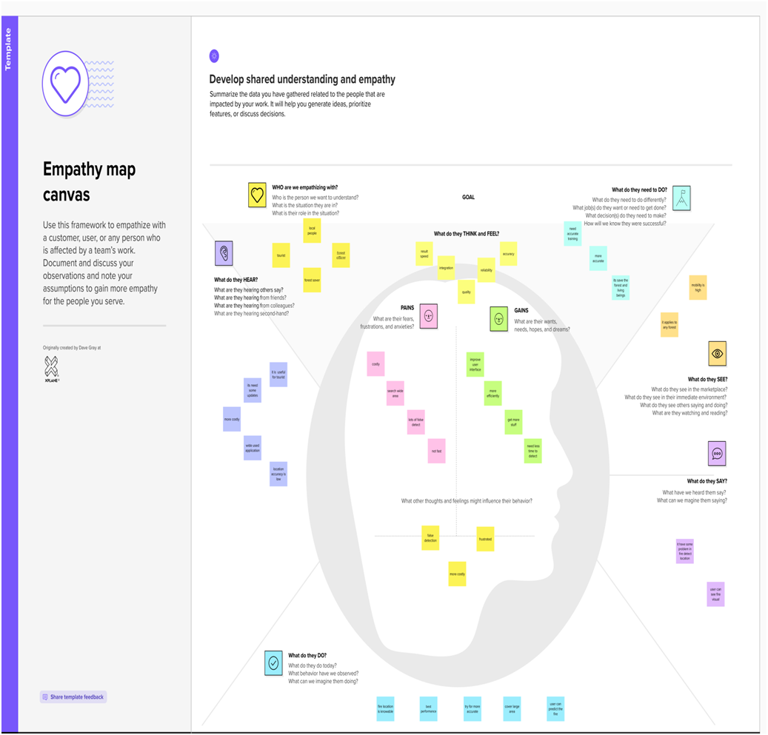

**3.2.BRAINSTORMING :**

**Problem Statements:**

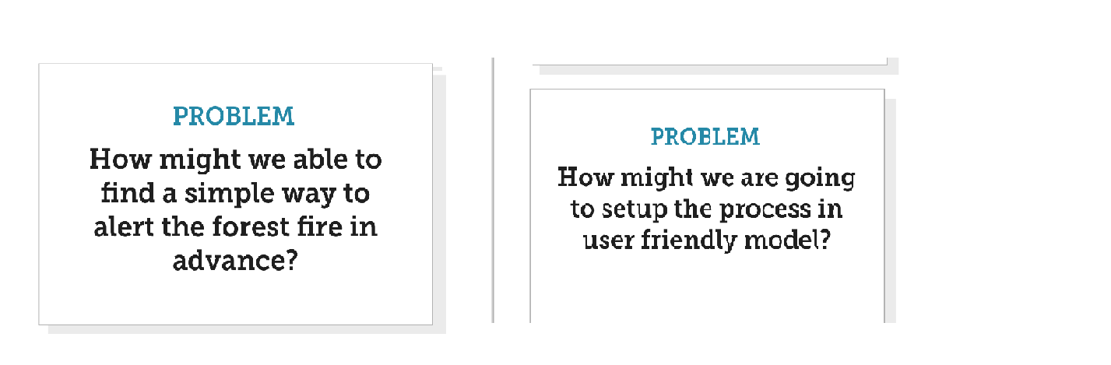

**Brainstorm, Idea Listing and Grouping**

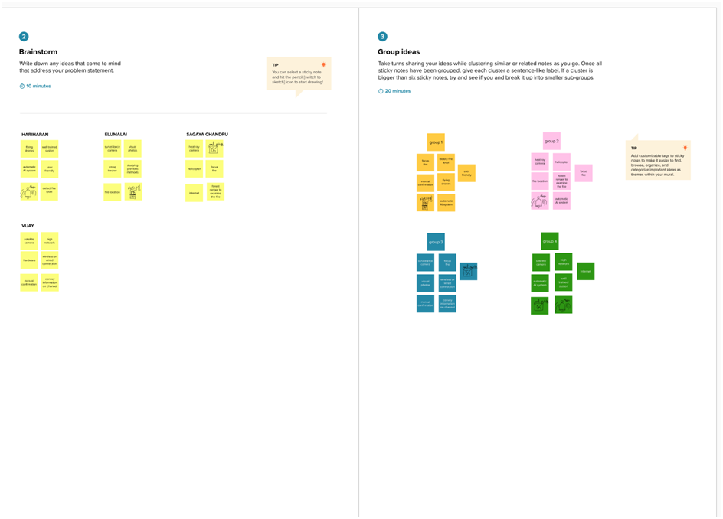

**Idea Prioritization**

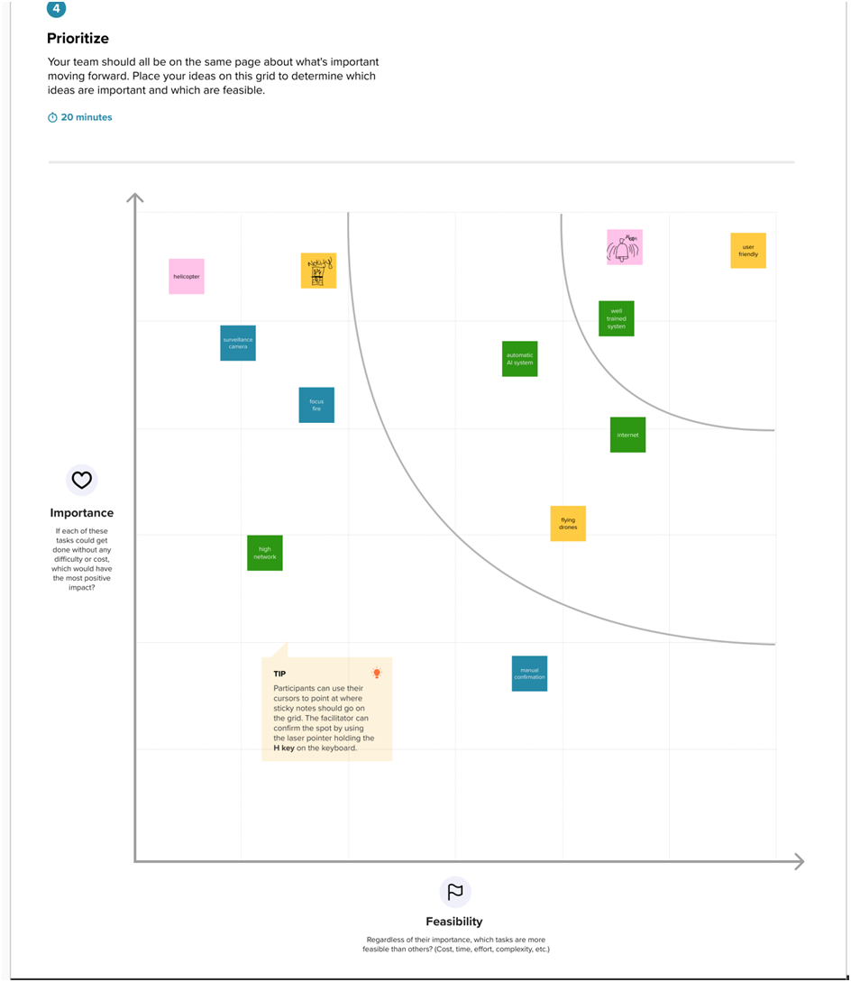

**3.3.PROPOSED SOLUTION:**

|  |  |  |
| --- | --- | --- |
| **S.No.** | **Parameter** | **Description** |
|  | Problem Statement (Problem to be solved) | Early detection of forest fire   * Detect the fire in initial stage. * Send a alert message to customer for attention . |
|  | Idea / Solution description | The idea or solution is:-   * Fire detection from video has become possible and more feasible in prevention of fire disaster due to deep convolutional neural networks (CNN) and embedded processing hardware. * Artificial intelligence (AI) methods generally require more computational time and hardware with powerful graphical processing unit (GPU). |
|  | Novelty / Uniqueness | * To design lightweight NN(neural networks) for embedded applications. |
|  | Social Impact / Customer Satisfaction | * Forest fires have become a serious threat to mankind. Besides providing shelter and protection to a large number of living beings, they have been a major source of food, wood, and a great supply of other products. * forests have played an important role in social, economic, and religious activities and have enriched human life in a variety of ways both material and psychological. |
|  | Business Model (Revenue Model) | * By using this model forest officer can easy to detect the forest fire immediately. * Alerting System used to save the forest and confirm tourist safety. |
|  | Scalability of the Solution | * There are more and more way for the scalability of the solution in which the model can be easily integrated and adoptable . |

**3.4.PROPOSED SOLUTION FIT:**

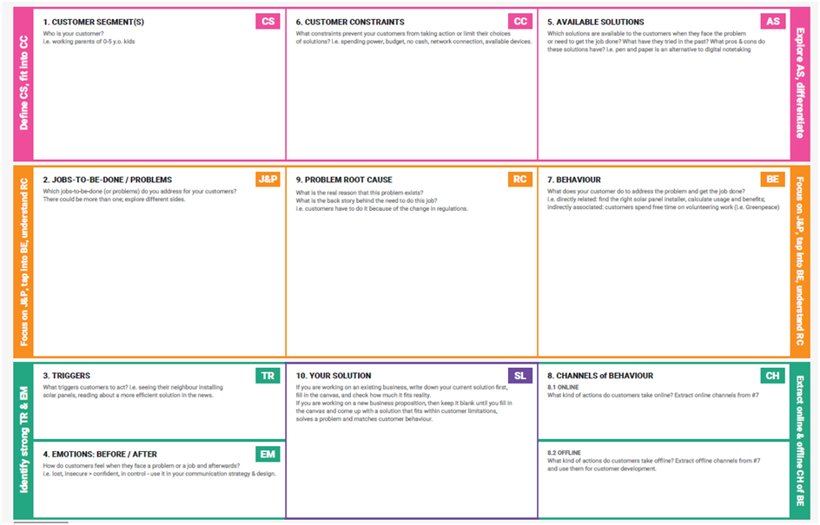

**4.REQUIREMENT ANALYSIS**

**4.1.FUNCTIONAL REQUIREMENTS:**

|  |  |  |
| --- | --- | --- |
| **FR No.** | **FunctionalRequirement(Epic)** | **SubRequirement(Story/Sub-Task)** |
| FR-1 | User Registration | Registration through Form Registration through Gmail Registration through LinkedIN |
| FR-2 | User Confirmation | Confirmation via Email  Confirmation via OTP |
| FR-3 | Image recognition | The system shall be able to take real inputs of satellites images and determine whether image contains fire or not. |
| FR-4 | Forest Monitoring | Forest are monitored 24/7 through |
| FR-5 | Alert | The system will send notification to the user when fire is detected |
| FR-6 | Detection | The system shall take training sets of fire and checks for fire or no fire or smoke |
| FR-7 | Operating system | The system can run as a service on Windows . |

**4.2.NON-FUNCTIONAL REQUIREMENTS**

|  |  |  |
| --- | --- | --- |
| **FR No.** | **Non-FunctionalRequirement** | **Description** |
| NFR-1 | **Usability** | Model is user friendly to use and very effective. |
| NFR-2 | **Security** | More secure environment. |
| NFR-3 | **Reliability** | Model is safe to install. |
| NFR-4 | **Performance** | Model will achieve high accuracy. |
| NFR-5 | **Availability** | Build model is available in all thetime |
| NFR-6 | **Scalability** | Model can handle large amount of data and can  easily adapt to every environment. |
| NFR-7 | **Testability** | Putting in more training data into the model can Improve the accuracy level of the system. |

**5.PROJECT DESIGN**

**5.1.DATA FLOW DIAGRAMS:**

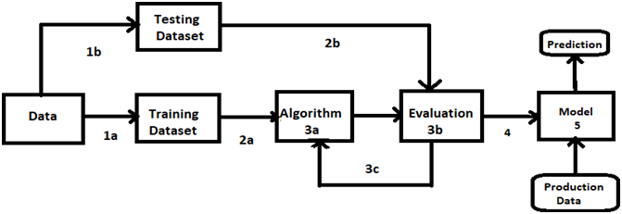

**1.Data set**

**2.Evaluate Dataset**

**3.Implement Algorithm**

**4.Evaluate accuracy of algorithms**

**5.Display Results**

**5.2. SOLUTION AND TECHNICAL ARCHIETECTURE:**

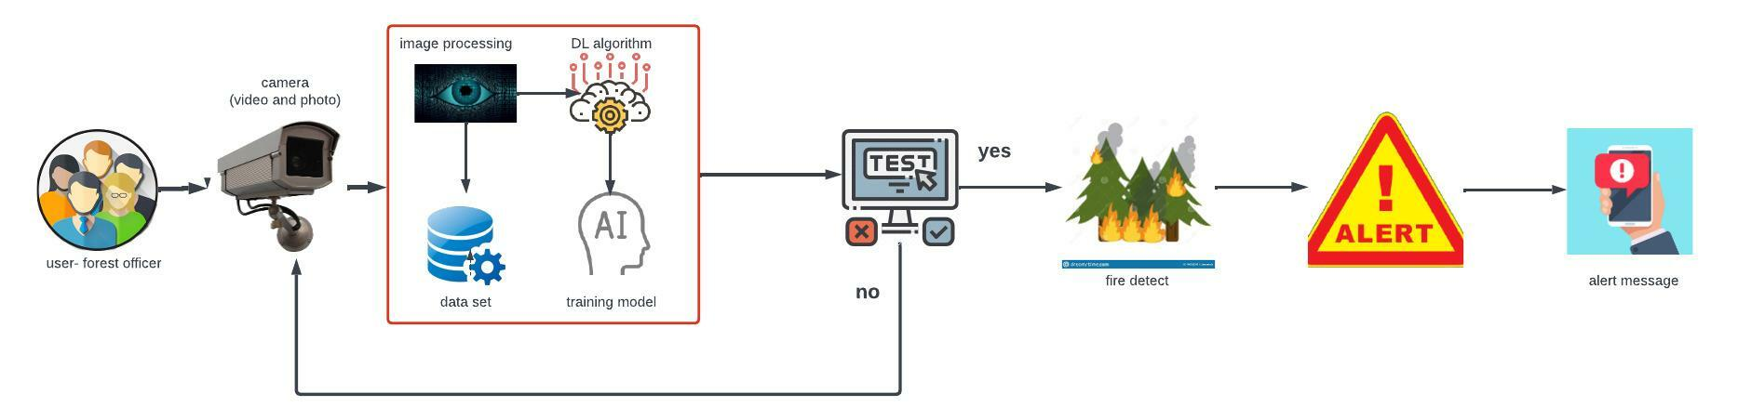

**5.3.USER STORIES:**

|  |  |  |  |  |  |  |
| --- | --- | --- | --- | --- | --- | --- |
| **UserType** | **Functional**  **Requirement(Epic)** | **User Story Number** | **UserStory/Task** | **Acceptance criteria** | **Priority** | **Release** |
| Customer  (Mobile user) | Registration | USN-1 | As a user,I can register for the application by entering my email, password, and confirming my password. | I can access my account/dashboard | High | Sprint-1 |
|  |  | USN-2 | As a user, I will receive confirmation email on ceIl phone have registered for the application | I can receive confirmation email & click confirm | High | Sprint-1 |
|  |  | USN-3 | As a user, I can register for the application through Facebook | I can register & access the dashboard with Facebook Login | Low | Sprint-2 |
|  |  | USN-4 | As a user , I can register for the application through Gmail |  | Medium | Sprint-1 |
|  | Login | USN-5 | As a user,I can log into the application by entering email & password |  | High | Sprint-1 |
|  | Dashboard |  |  |  |  |  |

**6. PROJECT PLANNING & SCHEDULING:**

**6.1. SPRINT PLANNING & ESTIMATION:**

|  |  |  |  |  |  |  |
| --- | --- | --- | --- | --- | --- | --- |
| **Sprint** | **Functional**  **Requirement**  **(Epic)** | **User Story**  **Number** | **User Story / Task** | **Story Points** | **Priority** | **Team**  **Members** |
| Sprint-1 | Download data set | USN-1 | The data is downloaded from the Kaggle website and then the data set is classified into training and testing images. | 10 | High | S. Hariharan |
| Sprint-1 | Image pre-processing | USN-1 | In Image processing technique the first step is usually importing the libraries that will be needed in the program.    Import Keras library from that library and import the ImageDataGenerator Library to the Python script.  The next step is definig the arguments for the ImageDataGenerator . Here the arguments which we are given inside the image data generator class are, rescale, shear_range, rotation range of image, and zoom range that we can consider for images.  The next step is applying the ImageDataGenerator arguments to the train and test dataset. | 10 | High | S. Hariharan  V.Elumalai  S.Sagaya chandru  S.Vijay |
| Sprint-2 | Training image | USN-2 | In this training phase the ImageDataGeneratorarguments is applied to the training images and the model is tested with several images and the model is saved. | 20 | High | |  | | --- | | S.Hariharan  V.Elumalai  S.Sagaya chandru  S.Vijay | |
| Sprint-3 | Testing image | USN-3 | In this testing phase the Image processing techniques is applied to the testing images and executed for prediction. | 20 | High | |  | | --- | | S.Hariharan  V.Elumalai  S.Sagaya chandru  S.Vijay | |
| Sprint-4 | Evaluation metrics and accuracy | USN-4 | In this phase the result, prediction, accuracy, and performance of the model are tested. | 20 | High | S. Hariharan  V.Elumalai  S.Sagaya chandru  S.Vijay |

**MILESTONE & ACTIVITY LIST:**

|  |  |  |  |  |
| --- | --- | --- | --- | --- |
| **Activity**  **Number** | **Activity Name** | **Detailed Activity Description** | **Task Assigned** | **Status** |
| **1.1** | Access Resources | Accesstheresources(courses)inproject dashboard. | All Members | COMPLETED |
| **1.2** | Rocket chat registration | Join the mentoring channel via platform& rocket-chat  mobile app. | All Members | COMPLETED |
| **1.3** | Access workspace | Access the guided project workspace. | All Members | COMPLETED |
| **1.4** | IBM Cloud registration | Register on IBM Academic Initiative &Apply Feature code for IBM  Cloud Credits. | All Members | COMPLETED |
| **1.5** | Project Repository Creation | Create GitHub account & collaboratewith Project  Repository in project workspace. | All Members | COMPLETED |
| **1.6** | Environment Setup | Set-up the Laptop / Computers basedon the pre-requisites for each technology track. | All Members | COMPLETED |
| **2.1** | Literature survey | Literature survey on the selected project& Information Gathering. | All Members | COMPLETED |
| **2.2** | Technology Training | Attend the technology trainings as perthe training Calendar. | All Members | COMPLETED |
| **2.3** | Empathy Map | Prepare EmpathyMapCanvasto  capture the user Pains &Gains,  Preparelistofproblemstatements | All Members | COMPLETED |
| **2.4** | Technology Training | Attend the technology trainings as perthe training Calendar. | All Members | COMPLETED |
| **2.5** | Brainstorming | List the ideas (at least 4 per each  team member) by organizing the  brainstorm session and prioritize  the ideas | All Members | COMPLETED |

|  |  |  |  |  |  |  |
| --- | --- | --- | --- | --- | --- | --- |
| **2.6** | Technology Training | | Attend the technology trainings as perthe training Calendar. | | All Members | COMPLETED |
| **3.1** | Proposed Solution Document | | | Prepare theproposedsolution document, which includes the novelty, feasibility of idea, business model, social  impact, scalability of solution, etc. | All Members | COMPLETED |
| **3.2** | Technology Training | | | Attend the technology trainings as perthe training Calendar. | All Members | COMPLETED |
| **3.3** | Problem - Solution fit &  SolutionArchitecture | | | Prepare problem - solution fit document& Solution Architecture. | All Members | COMPLETED |
| **3.4** | Technology Training | | | Attend the technology trainings as per  the training Calendar. | All Members | COMPLETED |
| **4.1** | Customer Journey Map | | | Prepare the customer journey maps to understand the user interactions & experiences with the application (entry to exit). | All Members | COMPLETED |
| **4.2** | Technology Training | | | Attend the technology trainings as perthe training Calendar. | All Members | COMPLETED |
| **4.3** | Functional Requirements&  Data Flow Diagrams | | | Prepare theFunctionalRequirement Document &DataFlow Diagrams. | All Members | COMPLETED |
| **4.4** | Technology Architecture | | | Prepare Technology Architecture  of the solution. | All Members | COMPLETED |
| **4.5** | Technology Training | | | Attend the technology trainings as  per the training Calendar. | All Members | COMPLETED |
| **5.1** | Milestone&Activity List | | | Prepare Milestone &  Activity List. | All Members | COMPLETED |
| **5.2** | Sprint Delivery Plan | | | Prepare Sprint Delivery Plan. | All Members | COMPLETED |
|  |  |  |  |  |  |  |

|  |  |  |  |  |
| --- | --- | --- | --- | --- |
| **6** | Data Collection | Collect datasets from different open  sources likekaggle.com, data.gov,  UCI machine learningrepository, etc. | All Members | COMPLETED |
| **7.1** | Image Preprocessing | Importingthe ImageDataGenerator  Library | All Members | COMPLETED |
| **7.2** | Image Preprocessing | Define the parameters/arguments for  ImageDataGenerator class. | All Members | COMPLETED |
| **7.3** | Image Preprocessing | ApplyingImageDataGenerator  functionality to trainset and test set. | All Members | COMPLETED |
| **8.1** | Model Building | Importing the model building libraries. | All Members | COMPLETED |
| **8.2** | Model Building | Initializing the model. | All Members | COMPLETED |
| **8.3** | Model Building | Adding CNN Layers. | All Members | COMPLETED |
| **8.4** | Model Building | Adding Dense Layers | All Members | COMPLETED |
| **8.5** | Model Building | Configuring the learning process | All Members | COMPLETED |
| **8.6** | Model Building | Training the Model | All Members | COMPLETED |
| **8.7** | Model Building | Save the model | All Members | COMPLETED |
| **8.8** | Model Building | Predictions | All Members | COMPLETED |
| **9.1** | Video Analysis | OpenCV for video processing. | All Members | COMPLETED |
| **9.2** | Video Analysis | Creating an account in Twilio service. | All Members | COMPLETED |
| **9.3** | Video Analysis | Sending alert message. | All Members | COMPLETED |
| **10.1** | Train CNN Model on IBM | Register for IBM Cloud | All Members | COMPLETED |
| **10.2** | Train CNN Model on IBM | Train Image Classification Model | All Members | COMPLETED |

**6.2.SPRINT DELIVERY SCHEDULE:**

|  |  |  |  |  |  |  |
| --- | --- | --- | --- | --- | --- | --- |
| **Sprint** | **Total Story Points** | **Duration** | **Sprint Start Date** | **Sprint End Date (Planned)** | **Story Points**  **Completed (as on**  **Planned End Date)** | **Sprint Release Date (Actual)** |
| Sprint-1 | 20 | 6 Days | 24 Oct 2022 | 29 Oct 2022 | 20 | 29 Oct 2022 |
| Sprint-2 | 20 | 6 Days | 31 Oct 2022 | 05 Nov 2022 | 20 | 05 Nov 2022 |
| Sprint-3 | 20 | 6 Days | 07 Nov 2022 | 12 Nov 2022 | 20 | 12 Nov 2022 |
| Sprint-4 | 20 | 6 Days | 14 Nov 2022 | 19 Nov 2022 | 20 | 19 Nov 2022 |

* 1. **REPORTS FROM JIRA:**

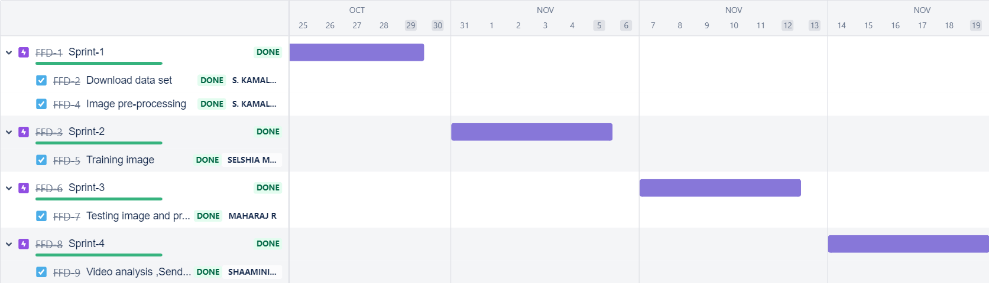

**7. CODING & SOLUTIONING**

**7.1.FEATURE 1:**

**1. IMAGE DATA GENERATOR:**

Keras ImageDataGenerator is used for getting the input of the original data and further, it makes the transformation of this data on a random basis and gives the output resultant containing only the data that is newly transformed. It does not add the data.

from keras.preprocessing.image import ImageDataGenerator

**2.PARAMETERS**

**2.1.Rescale:**

The ImageDataGenerator class can be used to rescale pixel values from the range of 0-255 to the range 0-1 preferred for neural network models. Scaling data to the range of 0-1 is traditionally referred to as normalization.

**2.2.Shear Range:**

Shear range means that the image will be distorted along an axis, mostly to create or rectify the perception angles. It's usually used to augment images so that computers can see how humans see things from different angles.

**2.3.Rotation range:**

ImageDataGenerator class allows you to randomly rotate images through any degree between 0 and 360 by providing an integer value in the rotation_range argument. When the image is rotated, some pixels will move outside the image and leave an empty area that needs to be filled in.

**2.4.Zoom Range:**

The zoom augmentation method is used to zooming the image. This method randomly zooms the image either by zooming in or it adds some pixels aroundthe image to enlarge the image. This method uses the zoom_range argument of the ImageDataGenerator class. It can specify the percentage value of the zooms either in a float**,** range in the form of an array.

**2.5.Horizontal Flip:**

Horizontal flip basically flips both rows and columns horizontally. So for this, It have to pass the horizontal_flip=True argument in the ImageDataGenerator constructor.

**3.CONVOLUTION NEURAL NETWORK:**

A CNN is a kind of network architecture for deep learning algorithms and is specifically used for image recognition and tasks that involve the processing of pixel data. There are other types of neural networks in deep learning, but for identifying and recognizing objects, CNNs are the network architecture of choice. The layers used in the CNN is Convolutional ,maxpooling, and flatten layer.

**3.1.Convolutional Layer:**

A convolutional layer is the main building block of a CNN. It contains a set of filters (or kernels), parameters of which are to be learned throughout the training. The size of the filters is usually smaller than the actual image. Each filter convolves with the image

Convolution layer is used for a image processing to blur and sharpen images, but also to perform other operations.

from keras.layers import Convolution2D

**3.2.Maxpooling Layer:**

Max pooling is a pooling operation that selects the maximum element from the region of the feature map covered by the filter.

from keras.layers import MaxPooling2D

**3.3.Flatten Layer:**

Flattening is used to convert all the resultant 2-Dimensional arrays from pooled feature maps into a single long continuous linear vector. The flattened matrix is fed as input to the fully connected layer to classify the image.

from keras.layers import Flatten

**4.DENSE LAYER:**

Dense Layer is used to classify image based on output from convolutional layers.

**7.2.FEATURE 2(CODE):**

**Importing Keras libraries**

import keras

# Importing ImageDataGenerator from Keras

from matplotlib import pyplot as plt

from keras.preprocessing.image import ImageDataGenerator

**Defining the Parameters**

train_datagen=ImageDataGenerator(rescale=1./255,shear_range=0.2,rotation_range=180,zoom_range=0.2,horizontal_flip=True)

test_datagen=ImageDataGenerator(rescale=1./255,shear_range=0.2,rotation_range=180,zoom_range=0.2,horizontal_flip=True)

**Applying ImageDataGenerator functionality to train dataset**

from google.colab import drive

drive.mount('/content/drive')

x_train=train_datagen.flow_from_directory('/content/drive/MyDrive/IBM PROJECT/dataset/DATA SET/archive/Dataset/Dataset/train_set',target_size=(64,64),batch_size=32,class_mode='binary')

# Applying ImageDataGenerator functionality to test dataset

x_test=test_datagen.flow_from_directory('/content/drive/MyDrive/IBM PROJECT/dataset/DATA SET/archive/Dataset/Dataset/test_set',target_size=(64,64),batch_size=32,class_mode='binary')

# Importing Model Building Libraries

#to define the linear Initialisation import sequential

from keras.models import Sequential

#to add layers import Dense

from keras.layers import Dense

#to create Convolutional kernel import convolution2D

from keras.layers import Convolution2D

#import Maxpooling layer

from keras.layers import MaxPooling2D

#import flatten layer

from keras.layers import Flatten

import warnings

warnings.filterwarnings('ignore')

# Initializing the model

model = Sequential()

# Adding CNN Layers

model.add(Convolution2D(32,(3,3),input_shape=(64,64,3),activation='relu'))

#add maxpooling layers

model.add(MaxPooling2D(pool_size=(2,2)))

#add faltten layer

model.add(Flatten())

# Add Dense layers

#add hidden layers

model.add(Dense(150,activation='relu'))

#add output layer

model.add(Dense(1,activation='sigmoid'))

# configuring the learning process

model.compile(loss='binary_crossentropy',optimizer="adam",metrics=["accuracy"])

# Training the model

model.fit_generator(x_train,steps_per_epoch=14,epochs=10,validation_data=x_test,validation_steps=4)

# Save the model

model.save("forest.h5")

# Predictions

#import load model from keras.model

from keras.models import load_model

#import image from keras

from tensorflow.keras.preprocessing import image

import numpy as np

#import cv2

import cv2

#load the saved model

model=load_model("/content/drive/MyDrive/IBM PROJECT/dataset/forest.h5")

img=image.load_img('/content/drive/MyDrive/IBM PROJECT/dataset/DATA SET/archive/Dataset/Dataset/test_set/with fire/FORESTFIRE (1).jpg')

x=image.img_to_array(img)

res=cv2.resize(x,dsize=(64,64),interpolation=cv2.INTER_CUBIC)

#expand the image shape

x=np.expand_dims(res,axis=0)

pred=model.predict(x)

pred = int(pred[0][0])

pred

int(pred)

pip install twilio

from twilio.rest import Client

if pred==0:

print('Forest fire')

account_sid='AC0f20fb7b8e71118fa14d874dc2384676'

auth_token='74902c8f190f5a4d288bbf5e3b48c84e'

client=Client(account_sid,auth_token)

message=client.messages \

.create(

body='forest fire is detected,stay alert',

#use twilio free number

from_='+18608542959',

#to number

to='+916380889559')

print(message.sid)

print("Fire detected")

print("SMS Sent!")

elif pred==1:

print('No Fire')

**Open cv for video processing**

pip install twilio

# from logging import WARNING

#import opencv library

import cv2

#import numpy

import numpy as np

#import image function from keras

from keras.preprocessing import image

#import load_model from keras

from keras.models import load_model

#import client from twilio API

from twilio.rest import Client

#import playsound package

# Creating An Account in Twilio Service

# Sending Alert Message

import cv2

import numpy as np

from google.colab.patches import cv2_imshow

from matplotlib import pyplot as plt

import librosa

from tensorflow.keras.preprocessing import image

from keras.models import load_model

# Create a VideoCapture object and read from input file

# If the input is the camera, pass 0 instead of the video file name

cap = cv2.VideoCapture('/content/drive/MyDrive/IBM PROJECT/dataset/datasetvideo.mp4')

# Check if camera opened successfully

if (cap.isOpened()== False):

print("Error opening video stream or file")

# Read until video is completed

while(cap.isOpened()):

# Capture frame-by-frame

ret, frame = cap.read()

if ret == True:

cv2_imshow(frame)

x=image.img_to_array(frame)

res=cv2.resize(x,dsize=(64,64),interpolation=cv2.INTER_CUBIC)

#expand the image shape

x=np.expand_dims(res,axis=0)

model=load_model("/content/drive/MyDrive/IBM PROJECT/dataset/forest.h5")

pred=model.predict(x)

pred = int(pred[0][0])

pred

int(pred)

if pred==0:

print('Forest fire')

break

else:

print("no danger")

break

# When everything done, release the video capture object

cap.release()

# Closes all the frames

cv2.destroyAllWindows()

from twilio.rest import Client

if pred==0:

print('Forest fire')

from twilio.rest import Client

account_sid='AC0f20fb7b8e71118fa14d874dc2384676'

auth_token='74902c8f190f5a4d288bbf5e3b48c84e'

client=Client(account_sid,auth_token)

message=client.messages \

.create(

body='forest fire is detected,stay alert',

#use twilio free number

from_='+18608542959',

#to number

to='+919150358042')

print(message.sid)

print("Fire detected")

print("SMS Sent!")

elif pred==1:

print('No Fire')

**8. TESTING**

**8.1.Test Cases:**

**8.2.User Acceptance Testing:**

**Purpose of Document:**

The purpose of this document is to briefly explain the test coverage and open issues of the [Early detection of forest fire using Deep Learning] project at the time of the release to User Acceptance Testing (UAT).

**Defect Analysis****:**

This report shows the number of resolved or closed bugs at each severity level, and how they were resolved

|  |  |  |  |  |  |
| --- | --- | --- | --- | --- | --- |
| **Resolution** | **Severity1** | **Severity2** | **Severity3** | **Severity4** | **Subtotal** |
| By Design | 5 | 1 | 1 | 1 | 8 |
| Duplicate | 1 | 0 | 3 | 0 | 4 |
| External | 2 | 3 | 0 | 1 | 6 |
| Fixed | 7 | 2 | 4 | 10 | 23 |
| Not Reproduced | 0 | 0 | 0 | 0 | 0 |
| Skipped | 0 | 0 | 1 | 1 | 2 |
| Won'tFix | 0 | 3 | 2 | 1 | 6 |
| Totals | 15 | 9 | 11 | 14 | 49 |

# Test Case Analysis:

# This report shows the number of test cases that have passed, failed, and untested

|  |  |  |  |  |
| --- | --- | --- | --- | --- |
| **Section** | **Total Cases** | **Not Tested** | **Fail** | **Pass** |
| Print Engine | 5 | 0 | 0 | 5 |
| Client Application | 30 | 0 | 0 | 30 |
| Security | 2 | 0 | 0 | 2 |
| Out source Shipping | 3 | 0 | 0 | 3 |
| Exception Reporting | 9 | 0 | 0 | 9 |
| Final Report Output | 4 | 0 | 0 | 4 |
| Version Control | 2 | 0 | 0 | 2 |

# 

**9.RESULTS**

**9.1.PERFORMANCSE METRICS:**

|  |  |  |
| --- | --- | --- |
| **S.No.** | **Parameter** | **Values** |
|  | Model Summary | As a threat of forest fire increases due to climate changes, the need for finding a detection system increases .The proposed Deep Learning-based model to predict early detection of forest fire. The Proposed model successfully classifies the images into fire and no fire, and sends an alert messages in case of fire. Thus, the Deep Learning algorithms proved their efficiency in detecting different objects. |
|  | Accuracy | Training Accuracy - 95%   Validation Accuracy - 95% |

**10.ADVANTAGES & DISADVANTAGES**

**ADVANTAGES:**

1.Ability to cover areas at different altitudes and locations.

2.The results is quite accurate with the accuracy upto 95% .

3.Reliability - The model is very effective, inexpensive and easy to apply.

4.The model, it shows the 'fire' and 'no fire' images classified with high accuracy.

5.Video analysis of this model leads to low degree of misjudgment of fire detection.

**DISADVANTAGES:**

1.Individual learner is responsible for learning global information to avoid false positives.

2.The limited learning and perception ability of individual learners is not sufficient to make them perform well in complex tasks.

3.Proper connectivity and maintenance will be a complex task.

**11.CONCLUSION**

As a threat of forest fire increases due to climate changes, the need for finding a detection system increase .The proposed Deep Learning-based model to predict the early detection of forest fire. The Proposed model successfully classifies the images into fire and no fire, and sends an alert messages in case of fire. Thus, the Deep Learning algorithm proved their efficiency in detecting the forest fire.

**12.FUTURE SCOPE**

* Integrate live satellite data and process real time processing of the fires.
* Enchance the time complexity of the detection of forest fires to improve the speed.
* These accidents can be controlled to a greater extend.
* Forest fire leads to destruction of excess of species, by using this technique it will save the life and environment.

**13.APPENDIX**

**DEMO VIDEO:**

Demo video link

# 

# 